**Arab Academy for Science Technology and Maritime Transport**

**College Of Computing and Information Technology**

**Department of Computer Science**

**Al-Rayah (Hyper-Market)**

**Presented by: Mark Mechail, Mostafa Tarek, Ahmed Mohamed, Mohamed Abdullah**

**Presented to: Eng. Tamer Abdellatif**

Contents

Chapter 1 1

**Introduction** 1

**Brief Explanation:** 1

**Why the need for a Database?** 1

**The data we collected:** 1

Chapter 2 2

**Analyses:** 2

**Employees:** 2

**Departments**: 2

**Customers:** 2

**Products**: 2

**Invoices**: 3

**Delivery**: 3

Chapter 3 4

**Design**: 4

**1.munaully ERD:** 4

**2. Computerized ERD** 5

**3. manually Mapping** 7

4. **Computerized mapping** 8

Chapter 4 9

Implementation: 9

1-Insertion and selection for data 9

**Table of Figures:**

Figure 1. Al-Rayah 1 1

Figure 2. Al-Rayah 2 2

Figure 3 Al-Rayah 3 ERD 4

Figure 4 Al-Rayah 4 ERD2 5

Figure 5 Al-Rayah 5 Mapping 1 7

Figure 6 Al-Rayah 6 Mapping 2 8

Al-Rayah 7- insertion 9

Al-Rayah 8-selection 10

Al-Rayah 9-selection 10

Al-Rayah 10-selection 11

Al-Rayah 11-selection 11

Al-Rayah 12-selection 12

Al-Rayah 13-selection 13

Al-Rayah 14-selection 14

Al-Rayah 15-selection 14

Al-Rayah 16-selection 15

Al-Rayah 17-selection 16

Al-Rayah 18-selection 17

Al-Rayah 19-selection 18

Al-Rayah 20-selection 19

Al-Rayah 21-selection 20

Al-Rayah 22-selection 20

Al-Rayah 23-selection 21

Al-Rayah 24-selection 21

Al-Rayah 25-selection 22

Al-Rayah 26-insertion 23

Al-Rayah 27-insertion 23

Al-Rayah 28-insertion 24

Al-Rayah 29-insertion 24

Al-Rayah 30-insertion 25

Al-Rayah 31-insertion 25

Al-Rayah 32-insertion 26

Al-Rayah 33-GUI 26

Al-Rayah 34-GUI 27

Al-Rayah 35-GUI 27

Al-Rayah 36-GUI 28

Al-Rayah 37-GUI 28

Al-Rayah 38-GUI 29

Al-Rayah 39-GUI 29

Al-Rayah 40-GUI 30

Al-Rayah 41-GUI 30

Al-Rayah 42-GUI 31

Al-Rayah 43-GUI 31

Al-Rayah 44-GUI 32

Al-Rayah 45-GUI 32

Al-Rayah 46-GUI 33

Al-Rayah 47-GUI 33

Al-Rayah 48-GUI 34

Al-Rayah 49-GUI 35

**List of Tables**

Table of Abbreviations 1 v

**Table 1. Table of Abbreviations**

|  |  |
| --- | --- |
| ID | Identification number |
| BD | Birth date |
| **SSN** | Social security number |

# Cars parked on the side of a street Description automatically generated with medium confidenceChapter 1

Figure 1. Al-Rayah 1

## **Introduction**

### **Brief Explanation:**

Our project is aimed to imitate the Rayah Hyper-Market database including all its aspects, entities and attributes. During the first phase of our project, we gathered data from Rayah’s employees and management team in-order to better our understanding of their systems and databases, during which the following information was acquired.

### **Why the need for a Database?**

A hyper-market is one of the most essential services ever since the dawn of man, markets have always been a factor in daily life. Therefore, to facilitate how markets (or in our case, a hyper-market), databases are needed for multiple reasons, to name a few, they help ease the employees work and allow them to gather data about products and customers more easily which in return adds to customer satisfaction. It also helps by providing more easy-to-access data to the management about their employees which ensures a safer and more reliable environment in the workplace. Overall databases help improve the following aspects: Safety & Security, Data collection, Data accessing and Customer Satisfaction. That’s why databases are essential and that’s the main purpose of our project.

### **The data we collected:**

During our research we figured out that the way they manage their database is by connecting all branches to a single server, that way all promotions and discounts are connected between all branches across the country, we’ve also found out that their database consists of four main entities (tables), and they are:

* Employees
* Departments
* Customers
* Products
* Delivery

# Chapter 2

## **Analyses:**

Each of which carry the data following the topic that titles them. Each of them carry multiple attributes as follows:

### **Employees:**

* EID
* EName
* EEmail
* EAddress
* ESSN
* EDepartment
* A picture containing text, indoor, food, shop

  Description automatically generatedEMarital_Status

Figure 2. Al-Rayah 2

* EDegree
* EBD
* EMilitary_Status
* EWorkPermit
* ESalary
* EGender
* EPhoneNumber
* EPosition

### **Departments**:

* DNumber
* DName

### **Customers:**

* CID
* CPhoneNumber
* CName
* CAddress
* CEmail

### **Products**:

* PCode
* PName
* PExpiryDate
* PDepartment
* PPrice
* PStock
* POrigin

### **Invoices**:

* INo
* ITotal
* Icustomer
* IDate
* ITime

### **Delivery**:

* DeNo
* DeTime
* DeDate
* DeInvoice
* DeEmployee_Id
* DeAddress
* DeContact
* DeCustomer_Name

# Chapter 3

## **Design**:

### **1.munaully ERD:**

Figure 3 Al-Rayah ERD

### **2. Computerized ERD**

Figure 4 Al-Rayah ERD2

### **3. manually Mapping**

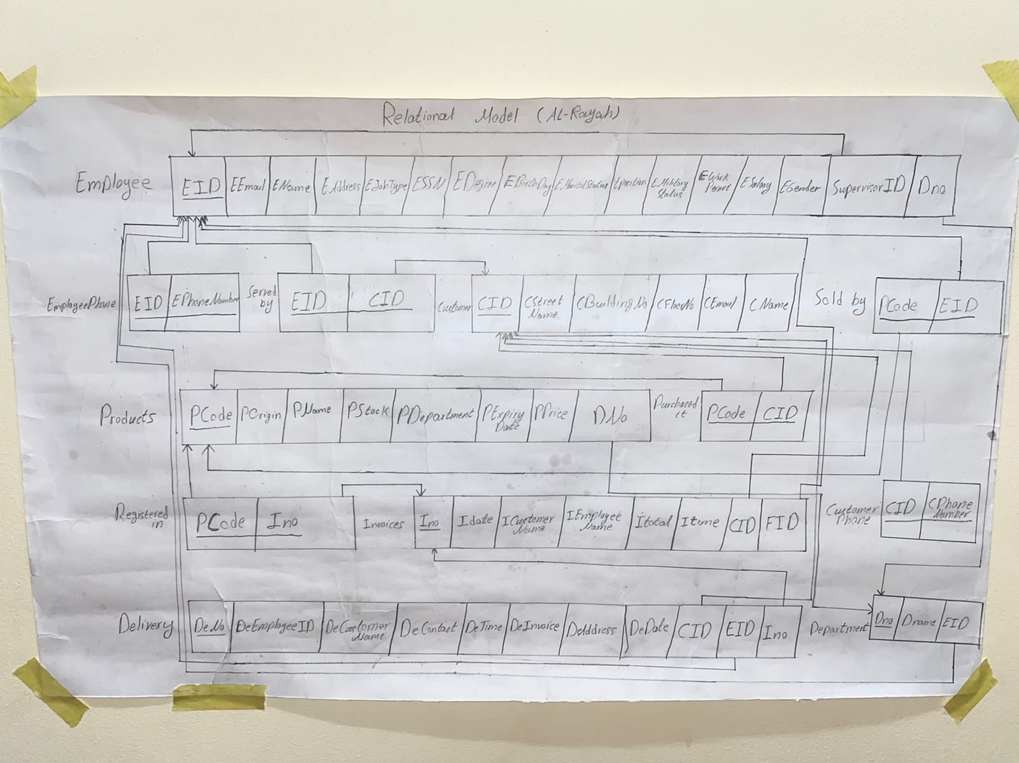

Figure 5 Al-Rayah Mapping 1

### 4. **Computerized mapping**

Figure 6 Al-Rayah Mapping 2

# Chapter 4

## Implementation:

### 1-Insertion , selection and Gui for data

Al-Rayah 7- insertion

Al-Rayah 8-selection

Al-Rayah 9-selection

Al-Rayah 10-selection

Al-Rayah 11-selection

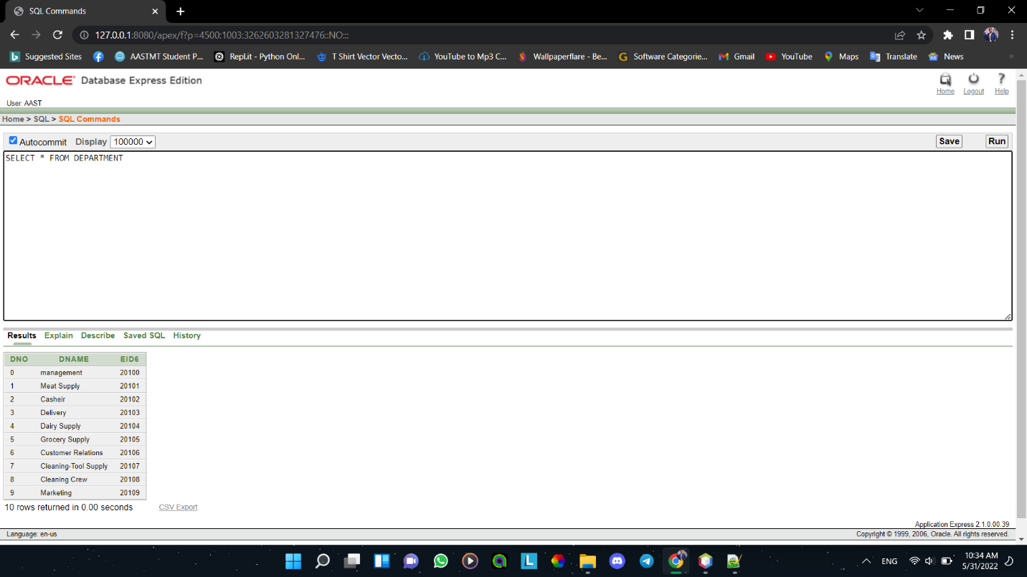

Al-Rayah 12-selection

Al-Rayah 13-selection

Al-Rayah 14-selection

Al-Rayah 15-selection

Al-Rayah 16-selection

Al-Rayah 17-selection

Al-Rayah 18-selection

Al-Rayah 19-selection

Al-Rayah 20-selection

Al-Rayah 21-selection

Al-Rayah 22-selection

Al-Rayah 23-selection

Al-Rayah 24-selection

Al-Rayah 25-selection

Al-Rayah 26-insertion

Al-Rayah 27-insertion

Al-Rayah 28-insertion

Al-Rayah 29-insertion

Al-Rayah 30-insertion

Al-Rayah 31-insertion

Al-Rayah 32-insertion

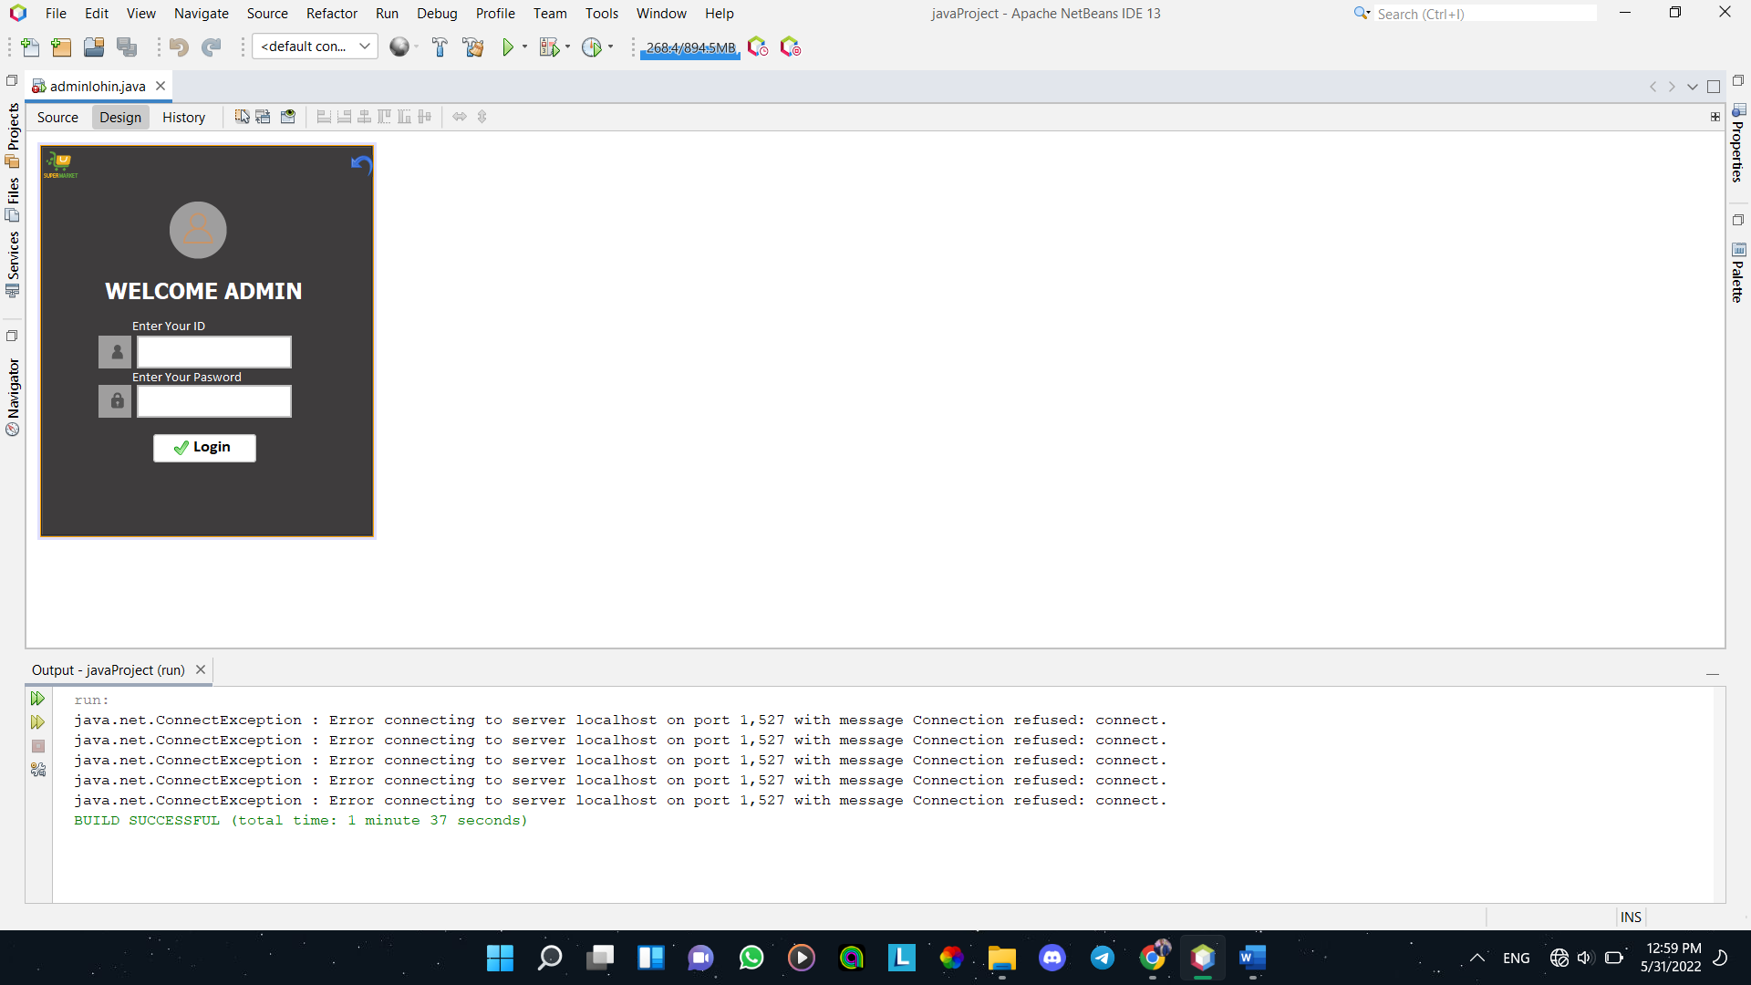

Al-Rayah -GUI

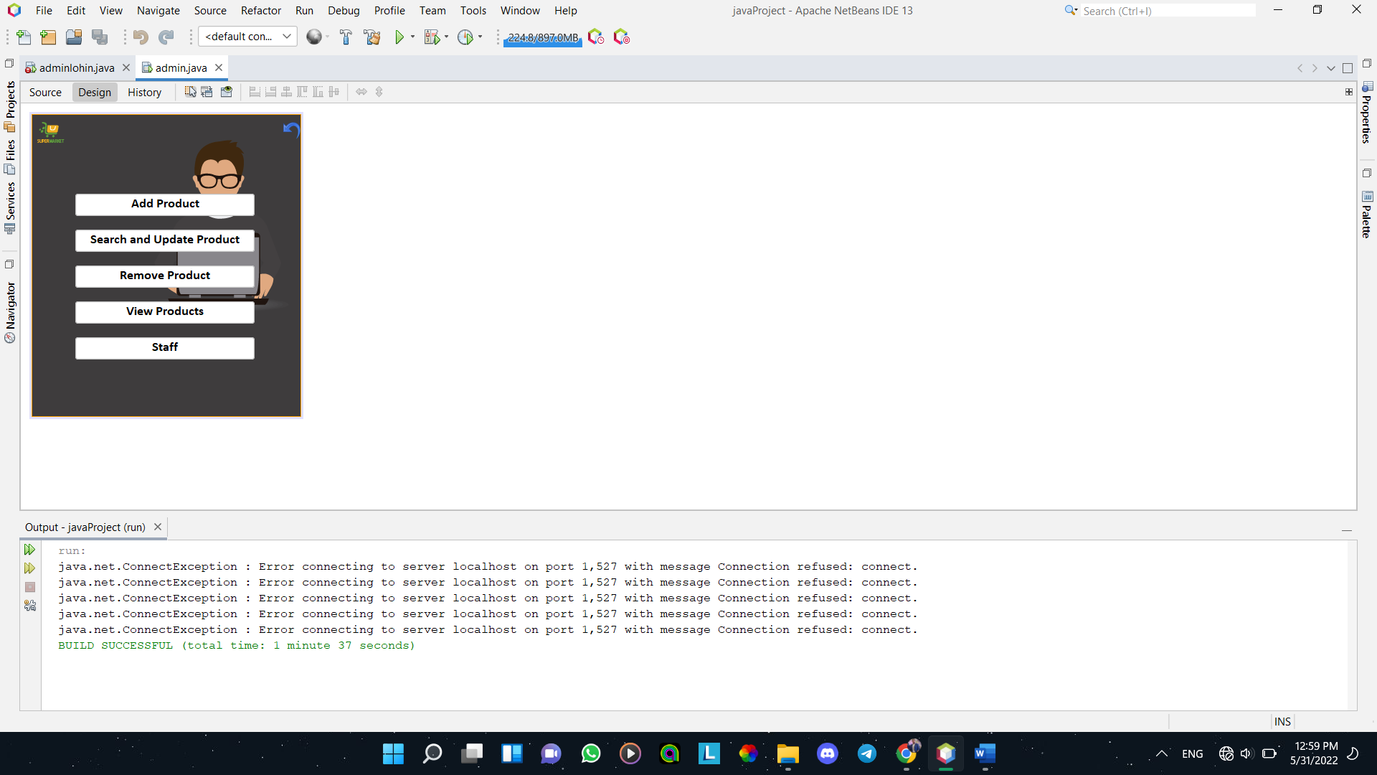

Al-Rayah -GUI

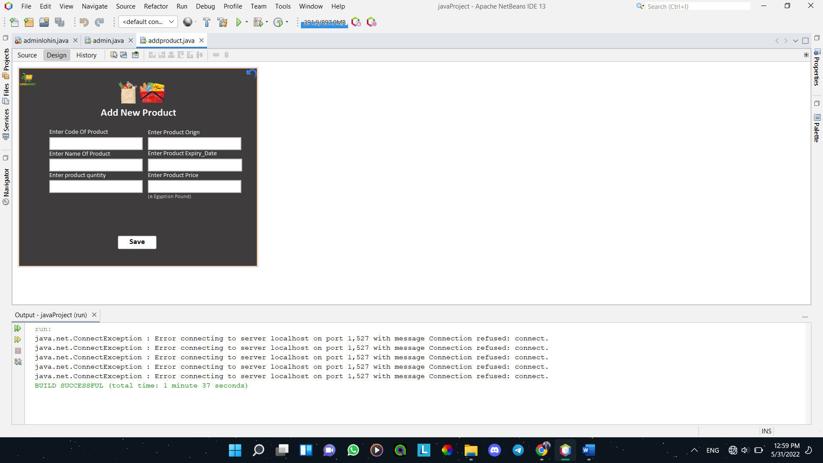

Al-Rayah -GUI

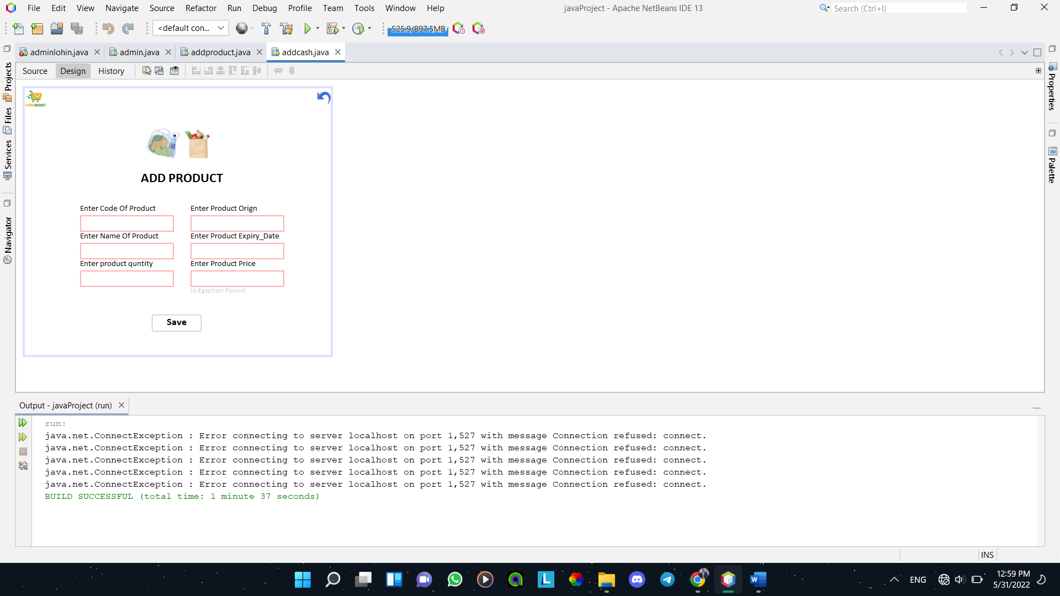

Al-Rayah -GUI

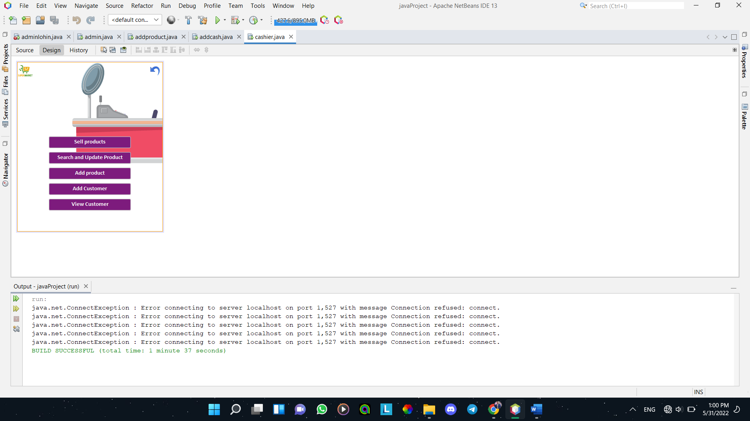

Al-Rayah -GUI



Al-Rayah -GUI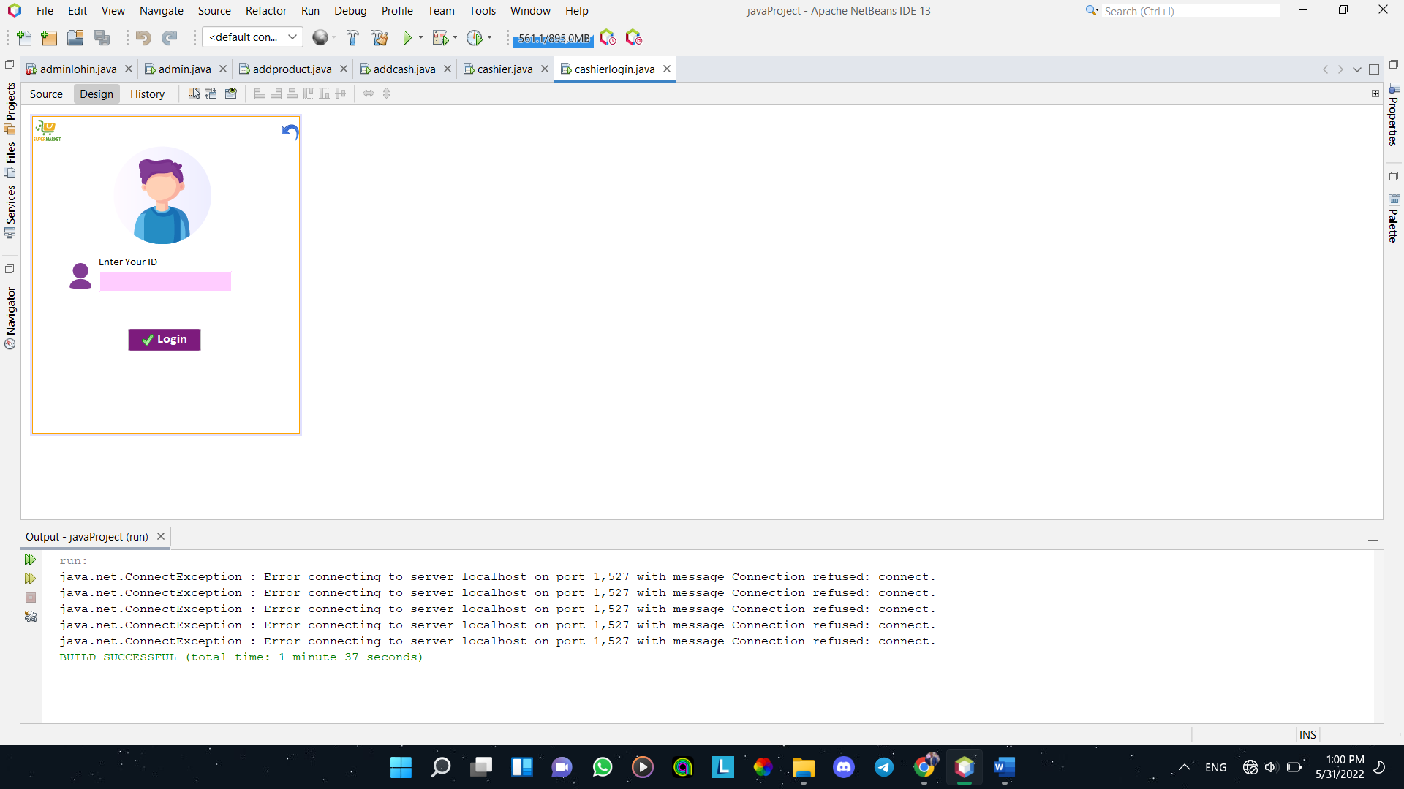

Al-Rayah -GUI

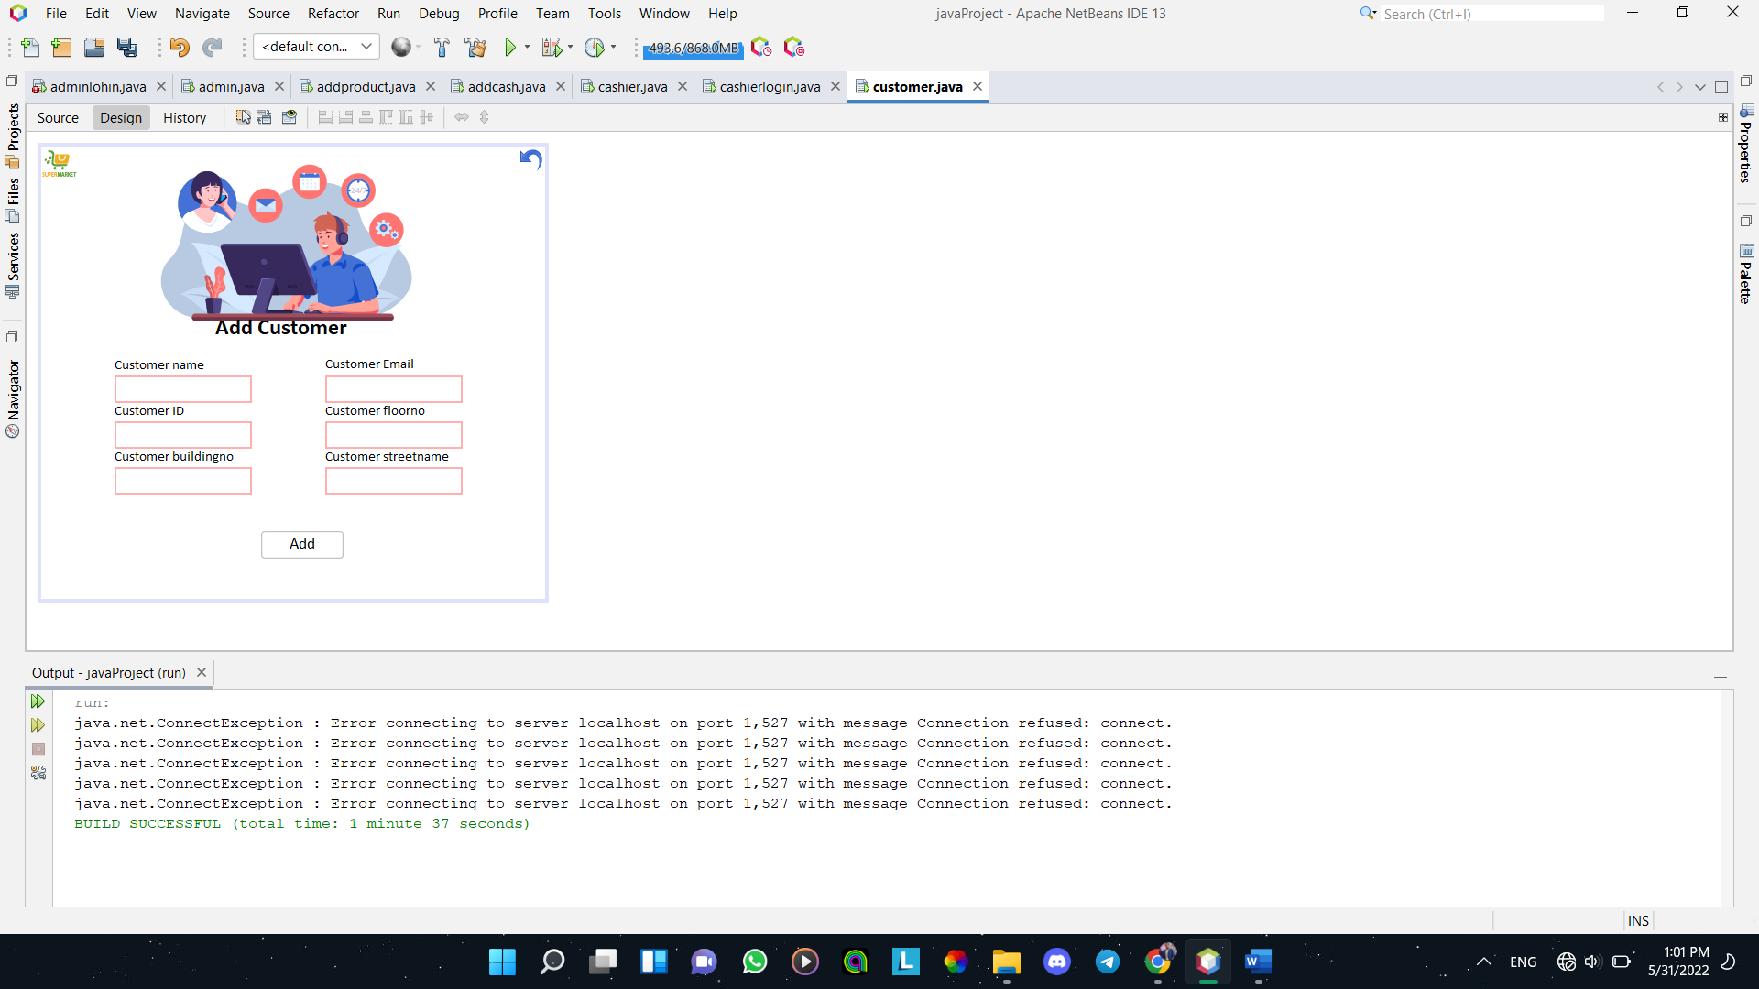

Al-Rayah -GUI

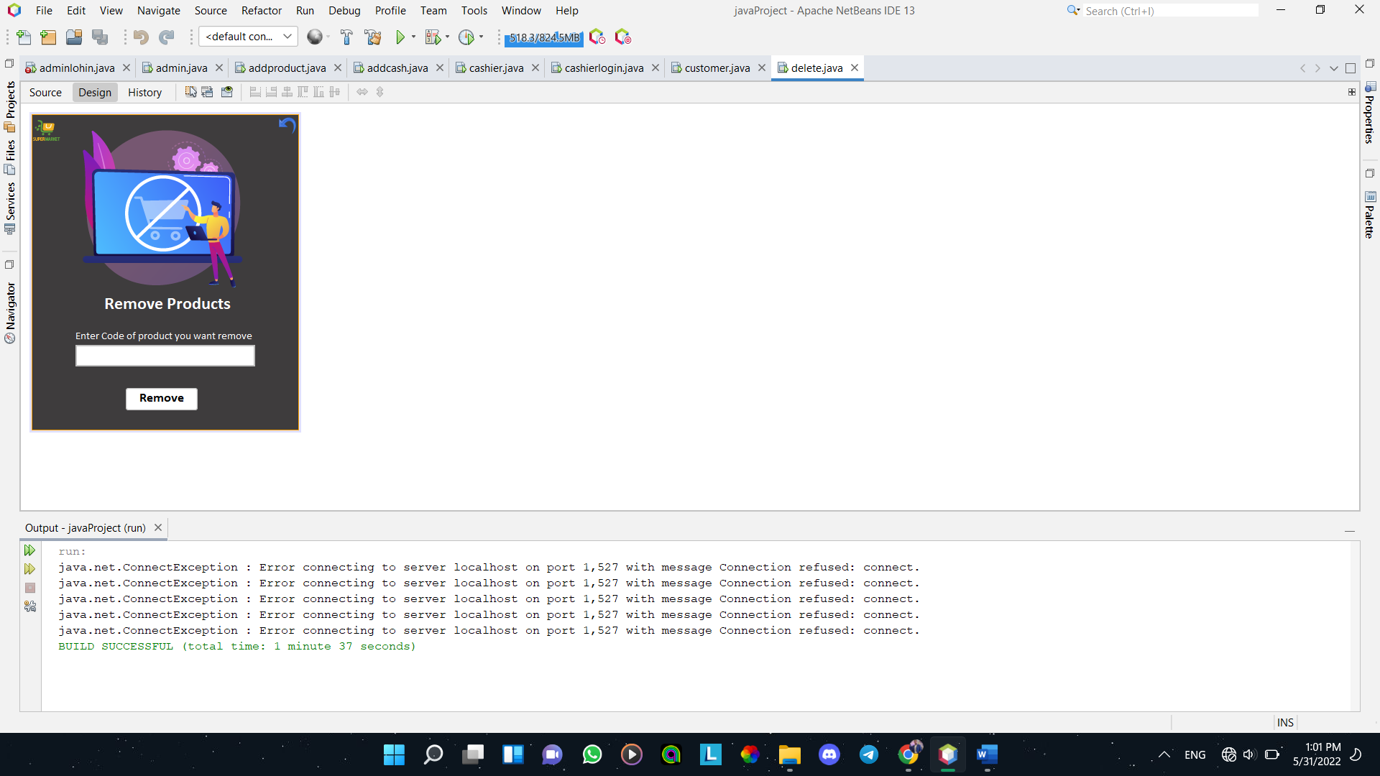

Al-Rayah -GUI

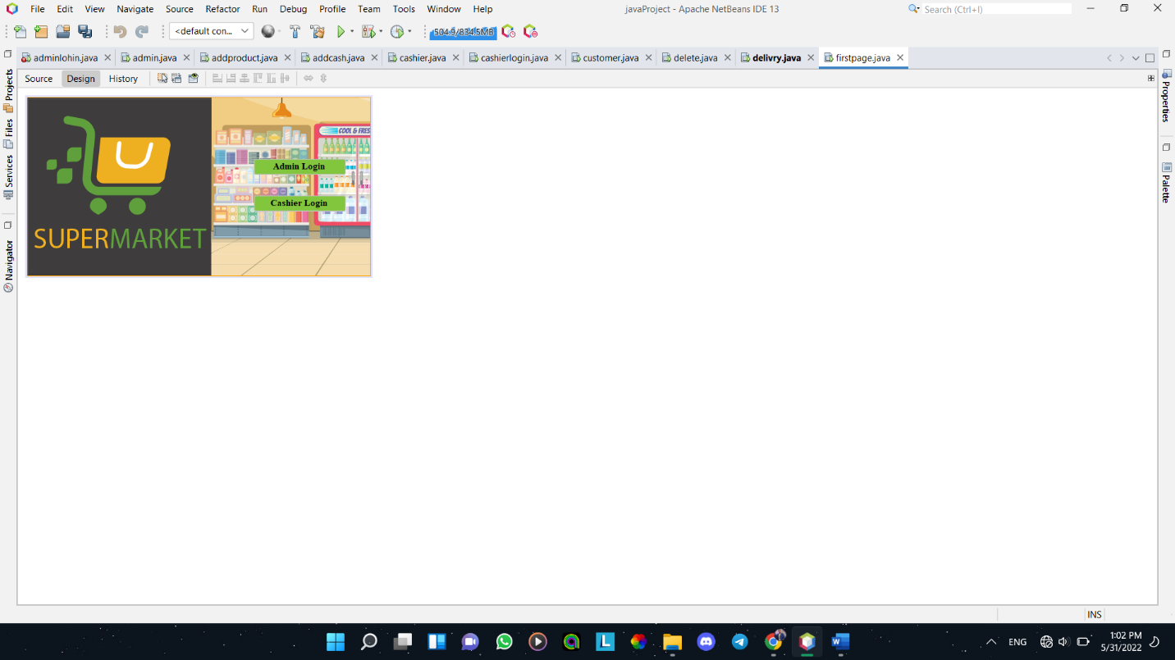

Al-Rayah -GUI

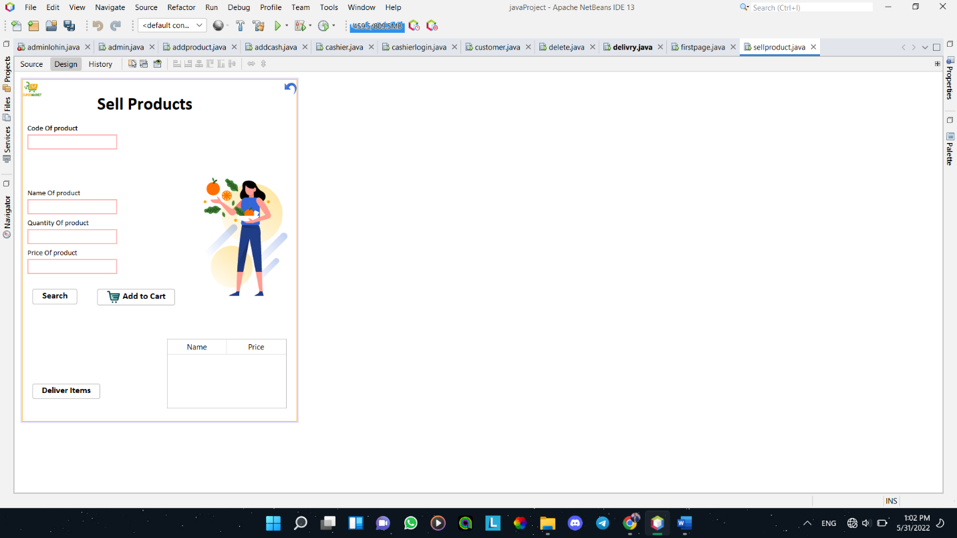

Al-Rayah -GUI

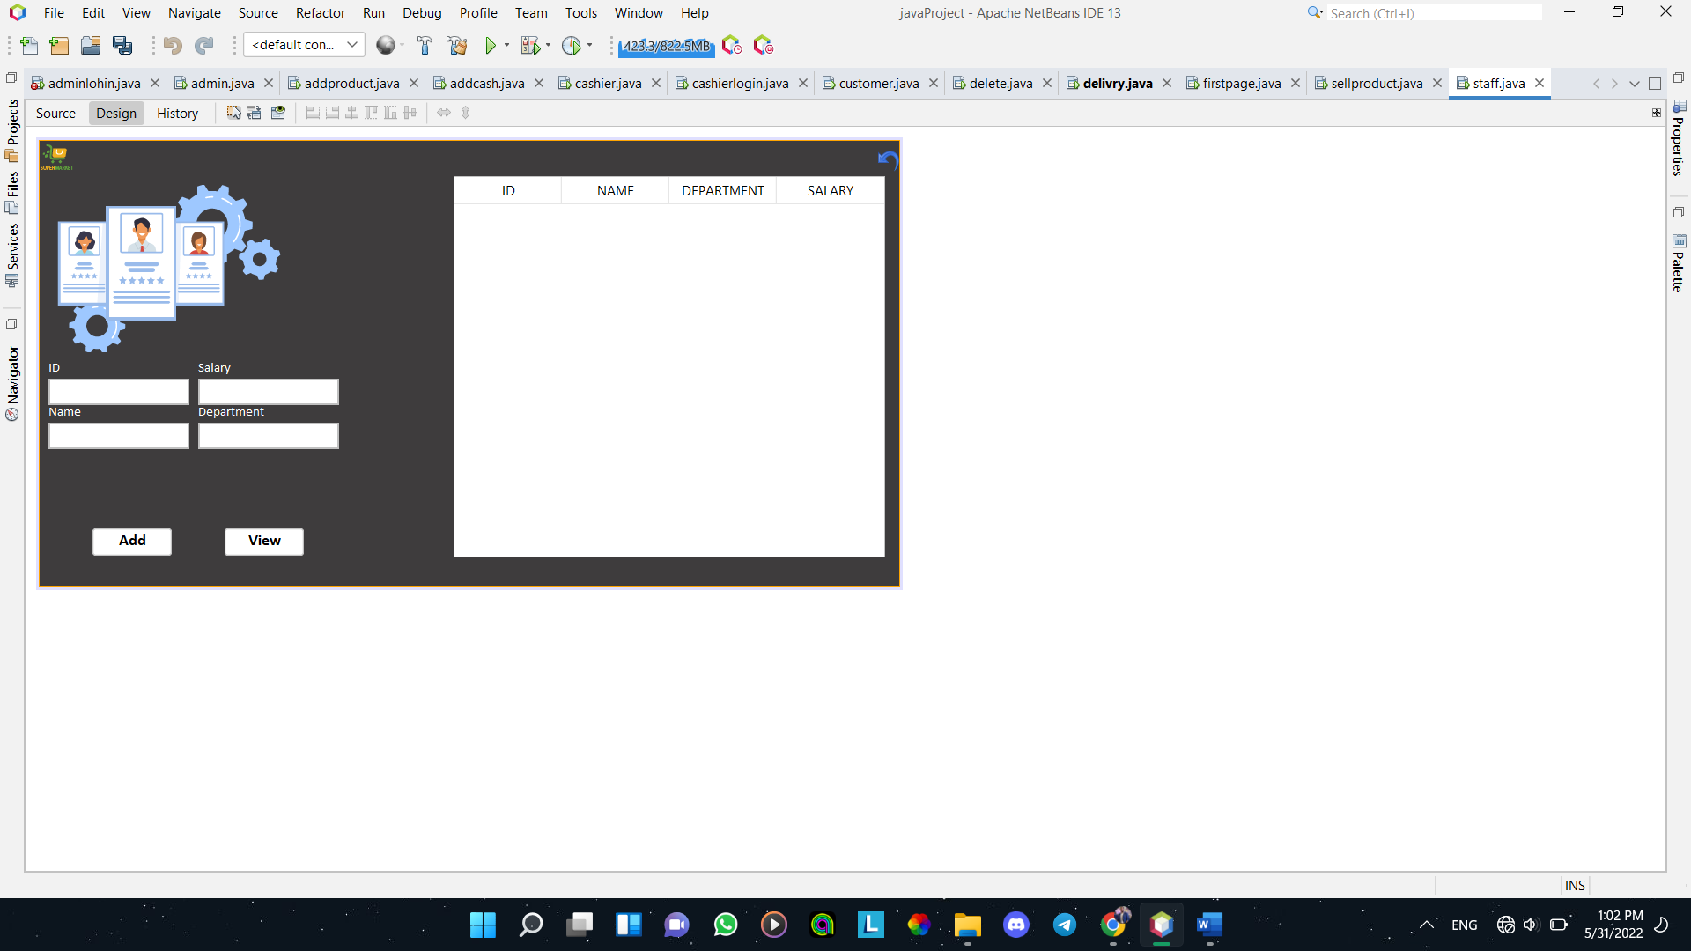

Al-Rayah -GUI

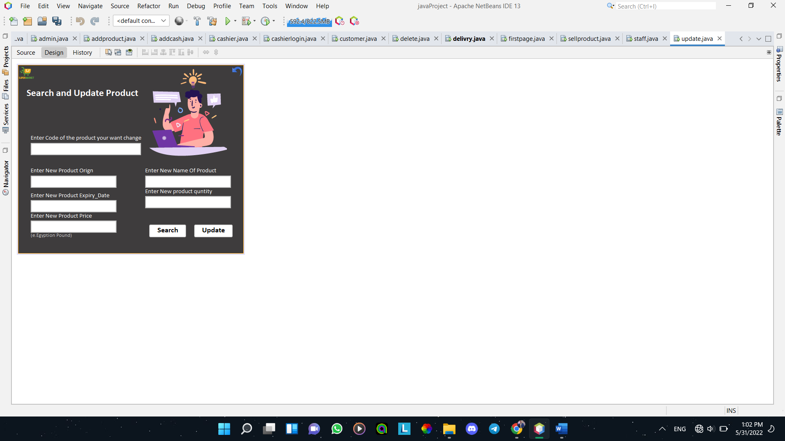

Al-Rayah -GUI

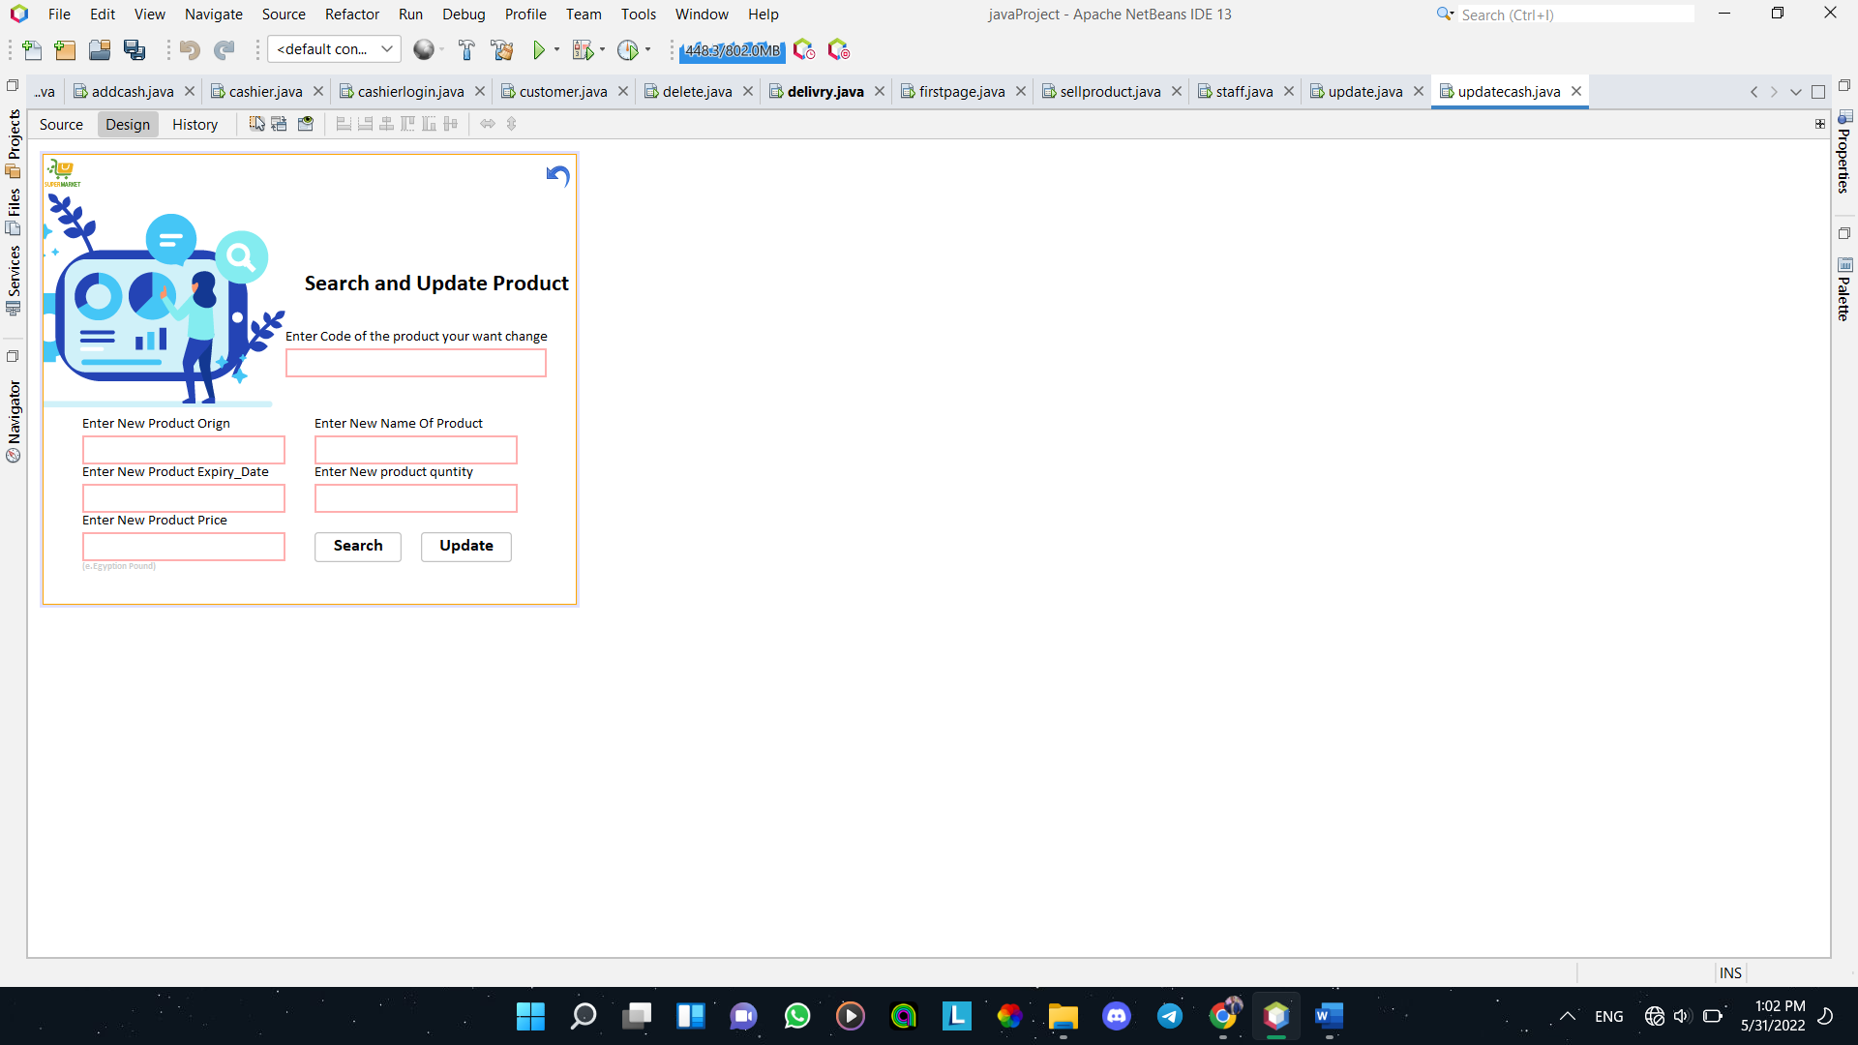

Al-Rayah -GUI

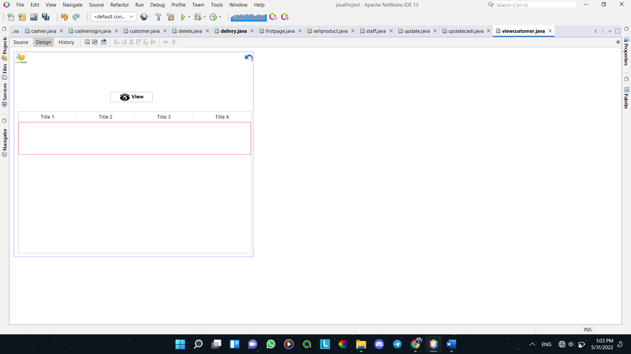

Al-Rayah -GUI

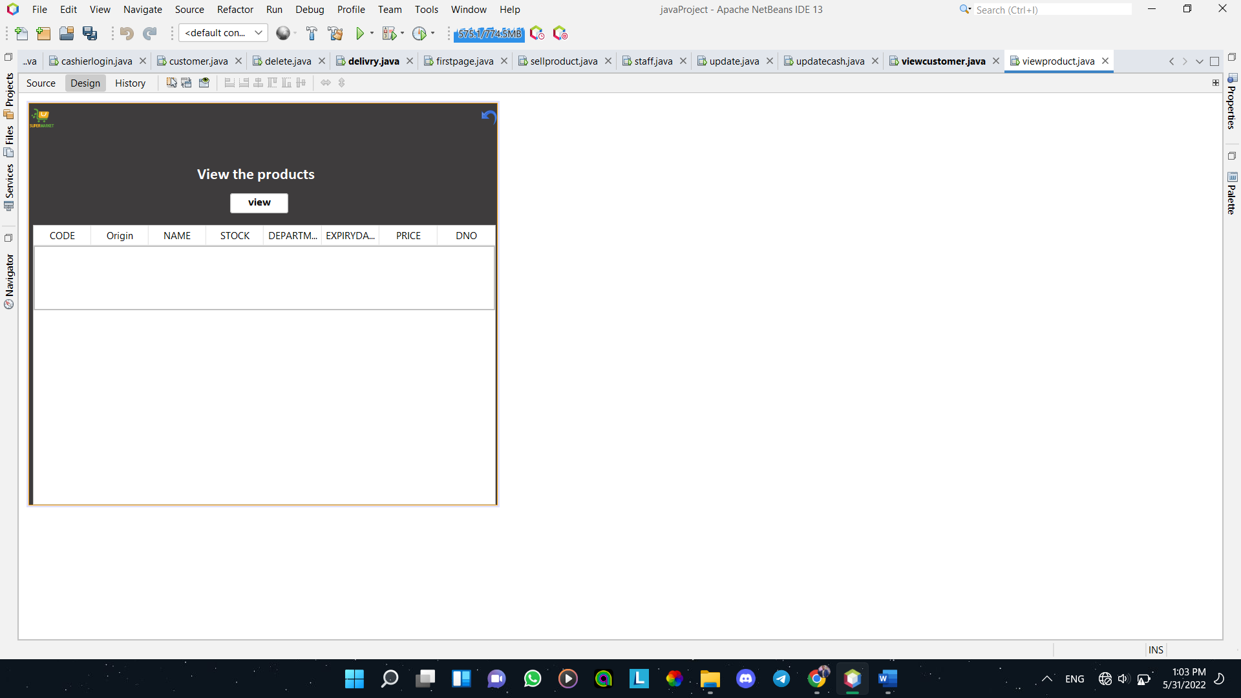

Al-Rayah -GUI

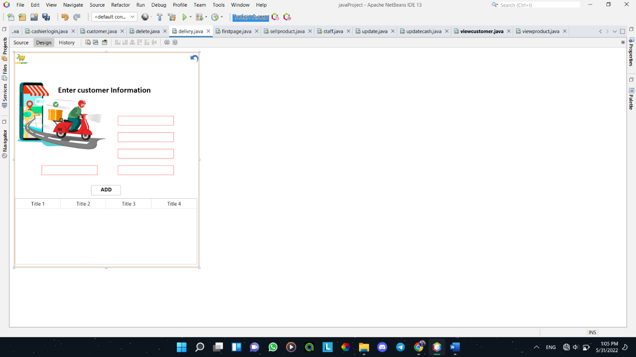

Al-Rayah -GUI